NAME:KAVIPREETHA R

REG NO:727721EUIT074

SOFTWARE TESTING CC2

YATRA:

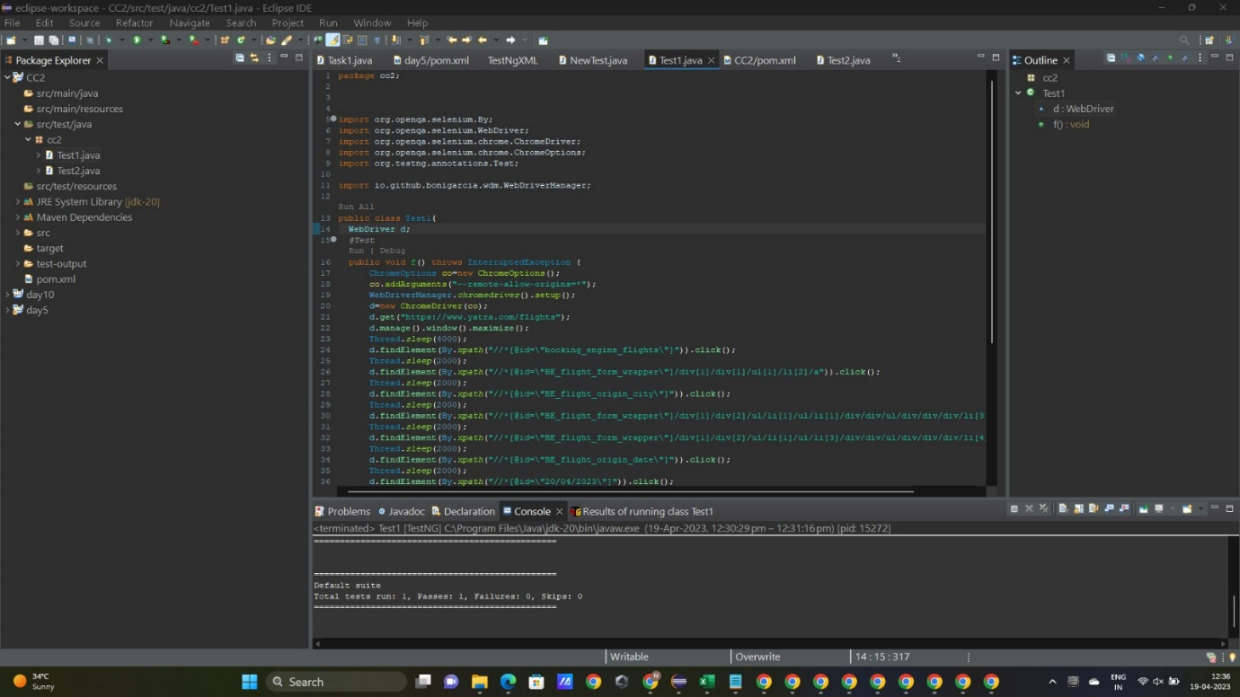



OUTPUT:



